Higher-order models and Interactions

By this point you are probably feeling overwhelmed by the multitude of possibilities available for developing statistical models. You’re right! The alternatives are limitless. To add to the possibilities we’ve looked at so far, we’ll look at another model structure.

Example: A drug manufacturer is interested in optimizing its manufacturing process. They are interested in the optimal levels of temperature and pressure that produce the highest quality product in a particular stage of the manufacturing process. Quality is measured as the yield of the process, or the percent of the batches that can be used in the next phase. They experiment with a variety of settings, generating the data in the file Drug Process.xls.

Develop a graph of the data using a Pivot Table. As we can see there is a non-linear relationship between both independent variables and the dependent variable (quality):

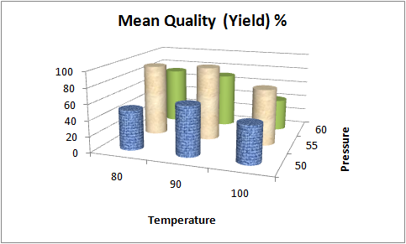

Based on the graph and our understanding of the process, we may want to try the following model:

Full Quadratic Model with Interaction Effects:

The regression output is given below.

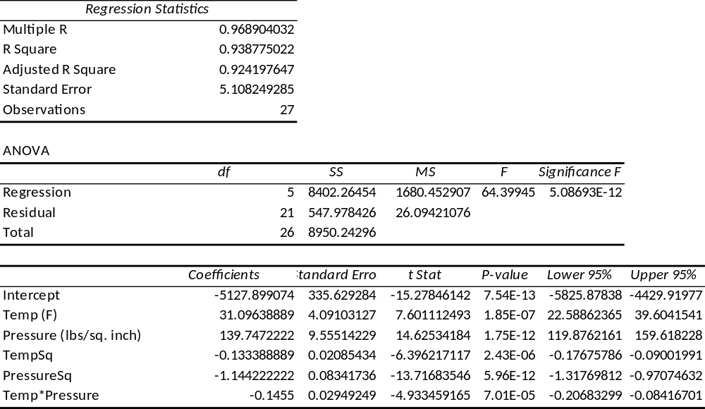

The condition for the function to be maximized is that the Hessian is negative semi definite.

- Comment on the quality of this model. Is the overall regression model statistically significant? Are the individual variables statistically significant?
Answer: Using our usual criteria for evaluating a model, this model is fine.

- Estimate the Quality of the process when Temperature is set at 92 F and the Pressure is 57 lbs./sq. inch.

Answer: Estimated quality is 88.977 in %

- Using this model find the optimal values for Temperature and Pressure.

Answer: Use either Calculus or Solver to show that the optimal quality they can achieve is 96.87
See next page

